**Your Paper's Title Starts Here: Please Center**

**use Times New Roman14**

FULL First Author1, a \***,** FULL Second Author2,b , FULL Last Author3,c

1Full address of first author, including country

2Full address of second author, including country

3List all distinct addresses in the same way

aemail, bemail, cemail

* please mark the corresponding author with an asterisk

**Abstract**

This template explains and demonstrates how to prepare your paper for *Journal of Educational Studies in Mathematics and Computer Science*.

All manuscripts must be in English, also the table and figure texts, otherwise, we cannot publish your paper. In the manuscript, use Times New Roman font throughout. List authors in 12-point font, followed by their full addresses (including country) and emails in 10-point font. For the rest of the paper, please use Times New Roman 12.

The template includes automatic numbering for figures, tables, formulas, and references, with preset line spacing, paper size, and margins. It is highly recommended to use the predefined settings. If you not, the document uses A4 format (21 x 29.7 cm or 8 x 11 inches) with the margins: bottom 0.7 in and top 1 in, right/left margins must be 0.9 in.

For formulas, please use Microsoft Equation for proper formatting and consistency. Do not number your paper.

**Keywords:** List the keywords covered in your paper. These keywords will also be used by the publisher to produce a keyword index.

1. **Introduction**

Use *italic* for emphasizing a word or phrase. Do not use boldface typing or capital letters except for section headings (cf. remarks on section headings, below).

1. **Organization of the Text**

**Section Headings.** The section headings are numbered in boldface capital and lowercase letters. Second level headings are typed as part of the succeeding paragraph (like the subsection heading of this paragraph).

**Tables.** Tables (refer with: Table 1, Table 2, ...) should be presented as part of the text, but in such a way as to avoid confusion with the text. A descriptive title should be placed *above* each table.

Table 1. The Greek alphabet

|  |  |  |
| --- | --- | --- |
| Letter name | Uppercase | Lowercase |
| Alpha | $$Α$$ | $$α$$ |
| Beta | $$Β$$ | $$β$$ |
| Gamma | $$Γ$$ | $$γ$$ |

**Special Signs**. For example, $α γ μ Ω () ≥ ± ● Γ \{110\}$ should always be written using Microsoft Equation.

**Figures.** Figures should be referred to within the text as Fig. 1, Fig. 2, etc., without including the full title of the figure. Captions, placed below the figures, should be clear and self-explanatory. Acceptable images include original drawings, high-quality photographs, or excellent photocopies. Care must be taken to align figures properly with the text, and images should have a resolution of 300 dpi for the best quality. (dots per inch).

Color figures are welcome because of the online version of the journal.

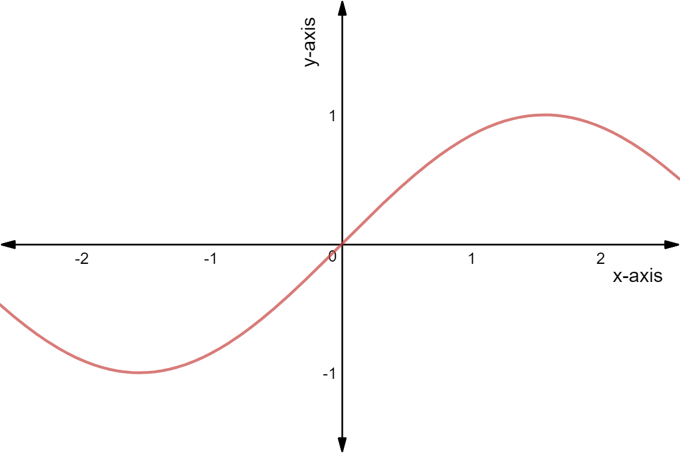

Fig. 1. Graph function

**Equations.** Equations should be referred to in the text as Eq. 1, Eq. 2, and so on. The spacing between the text and equations is set to 6pt. Equations must be numbered sequentially, with the number placed in parentheses at the right margin. If punctuation is required, it should be placed after the equation but before the equation number.

$${c^{2}=a}^{2}+b.$$

( 1 )

$$x=\frac{-b±\sqrt{b^{2}-4ac}}{2a}$$

( 2 )

**References and Citations**

Latest version of APA style should be used as the referencing style. Authors should maintain consistency across the references.

* Each citation inside the text must be included in the list of references. Alternatively, each reference should be cited inside the text.
* Where an author publishes two or more works in the same year, they should be differentiated using 2023a, 2023b, etc.
* When citing a study done by three or more authors, authors should use et al. within the main text, and provide the full names of all authors in the references section.
* In the text, after the quoted material, authors should provide the author's last name, publication year, and page numbers, if available, i.e. (Tall, 1991, p. 110).

The following are some examples:

*Journal articles*

Hansen, E. K. S., & Naalsund, M. (2022). The role of teacher actions for students’ productive interaction solving a linear function problem. *International Electronic Journal of Mathematics Education, 17*(3), em0685. <https://doi.org/10.29333/iejme/11921>

Tall, D. (2008). The transition to formal thinking in mathematics. *Mathematics Education Research Journal 20*, <https://doi.org/10.1007/BF03217474>

Verschaffel, L., Schukajlow, S., Star, J., & Van Dooren, W. (2022). Word problems in mathematics education: a survey. *ZDM Mathematics Education, 52,* 1–16. [https://doi.org/10.1007/s11858-020- 01130-4](https://doi.org/10.1007/s11858-020-%2001130-4)

*Books*

Abramovich, S., & Connell, M. L. (2021). *Developing deep knowledge in middle school mathematics*. Springer International Publishing.

Skemp, R. (1987). *The Psychology of Learning Mathematics*. Hillsdale, NJ: Lawrence Erlbaum Associates.

*Chapter in book*

Blomhøj, M., & Ärlebäck, J. (2018). Theory–practice relations in research on applications and modelling. In T. Dreyfus, M. Artigue, D. Potari, S. Prediger, & K. Ruthven (Eds.), *Developing Research in mathematics education: Twenty years of communication, cooperation and collaboration in Europe* (pp. 90–104). Routledge.

Greefrath, G. (2011). Using Technologies: New Possibilities of Teaching and Learning Modelling – Overview. In G. Kaiser, W. Blum, R. B. Ferri, & G. Stillman (Eds.), *Trends in Teaching and Learning of Mathematical Modelling* (pp. 301–304). Springer.

*Conference papers*

Lada, M. &, Forbregd. T. A. (2022). Student teachers’ proofs and refutations on cyclic quadrilaterals. In J. Hodgen, E. Geraniou, G. Bolondi & F. Ferretti. (Eds.), *Proceedings of the Twelfth Congress of European Research in Mathematics Education (CERME12)* (pp. 251–258).

Reid, D., Shinno, Y, & Fujita, T. (2022). International perspective on proof and proving: Recent results and future directions. In C. Fernández. et al. (Eds.). *Proceedings of the 45th Conference of the International Group for the Psychology of Mathematics Education* (Vol. 1, pp. 211–212).

Please visit the following page for more information APA style:

https://owl.purdue.edu/owl/research_and_citation/apa_style/apa_formatting_and_style_guide/general_format.html